**Medicare Project:-Screenshot Output**

***Home Page :-***

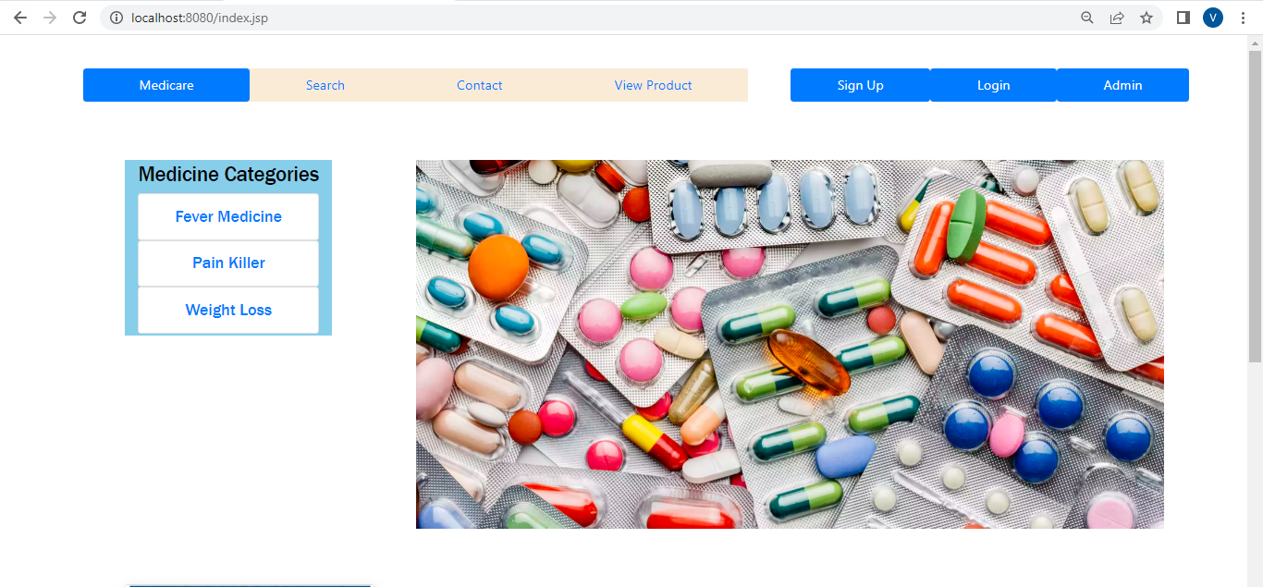



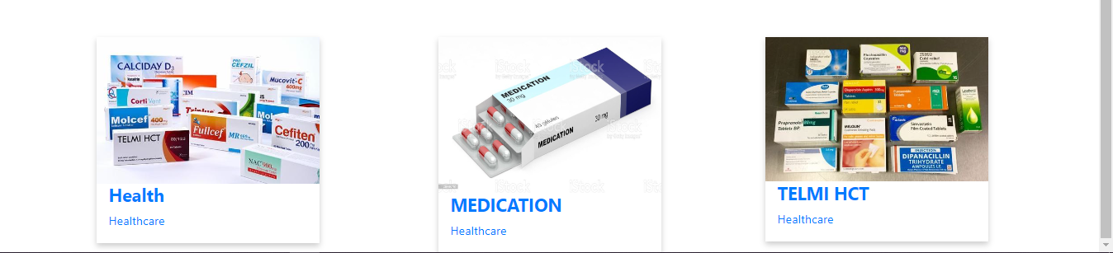

***User Register Page :-***



***Admin Login page: -***

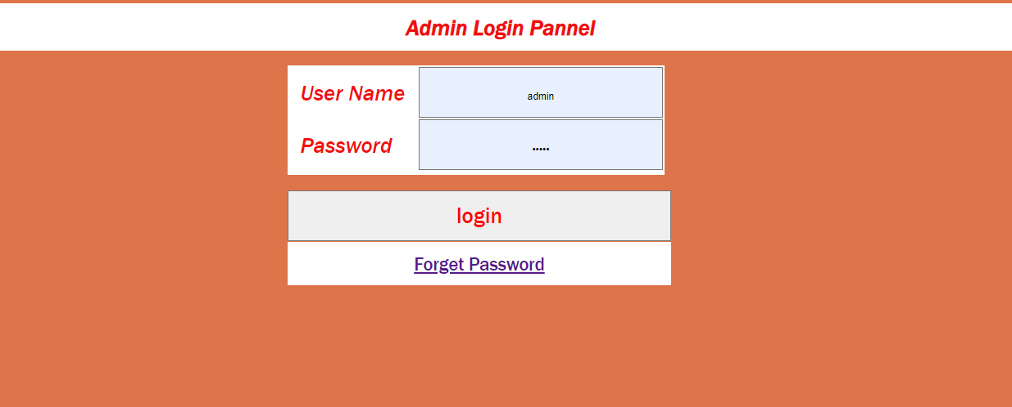

**Name:-Madhuri M. Wankhade**